**FITFOOD,**

**a Mobile Application for Food Delivery**

**User Guidelines for Admin Dashboard**

Contents

1) Logging In 3

2) Dashboard 4

3) Viewing Different Details 6

a) Order Details 6

b) Categories Details 6

c) Menu Details 9

4) Logging Out 12

# 1) Logging In

The admin will be able to log in to the dashboard by filling in a form using their Username and Password. They must fill the required fields and are logged in only if the credentials match.

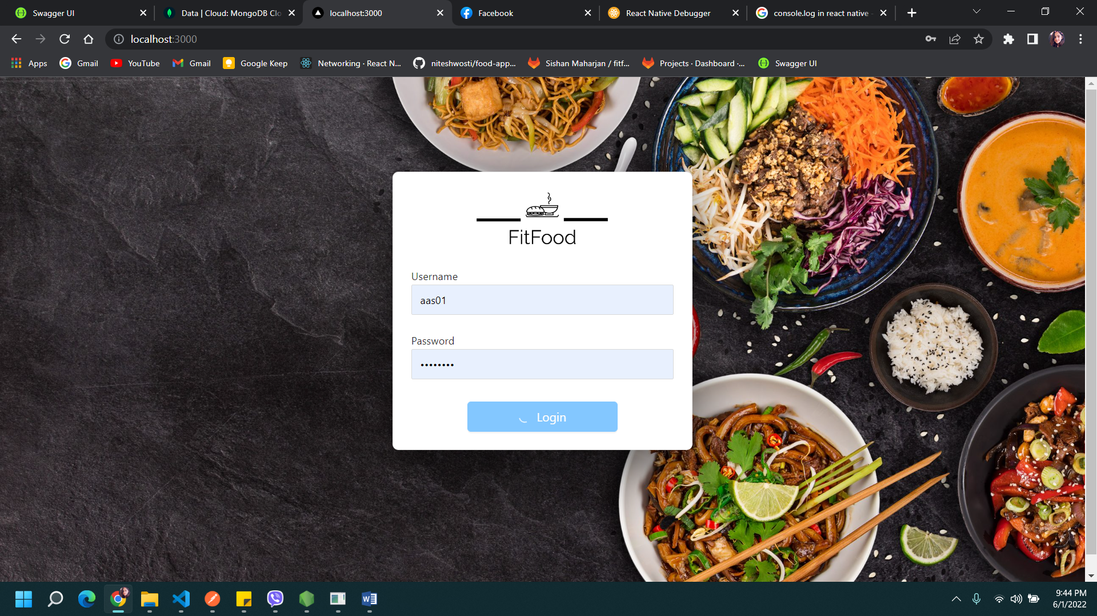

# 2) Dashboard

When the admin is logged in, the dashboard is displayed with various features where the admin can view orders, categories and menu.

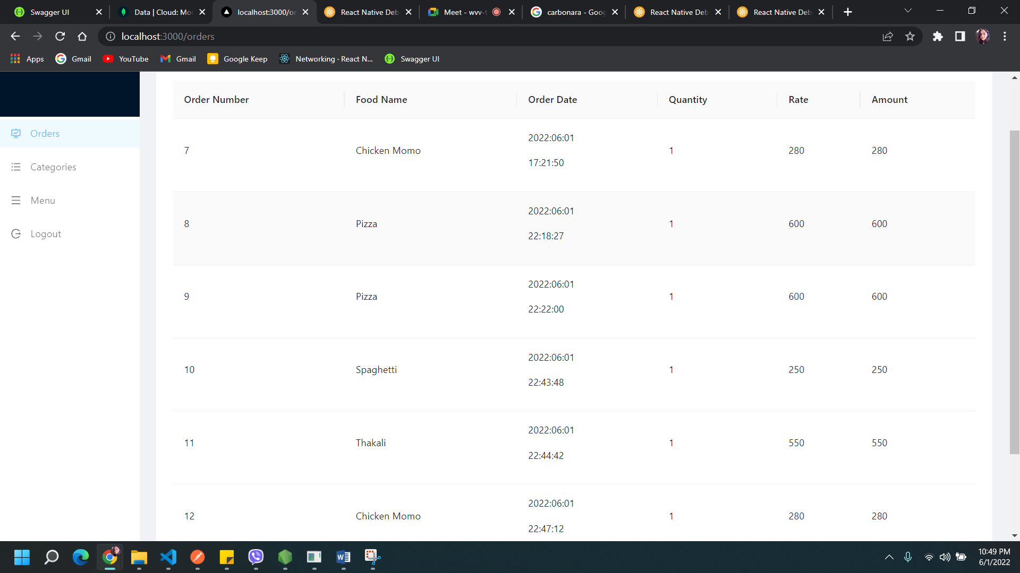

# 3) Viewing Different Details

The admin can select an option to view the details on the specified topic. After logging into the dashboard, the admin will be able to access the following information:

## a) Order Details

By clicking on the Orders on side menu bar, admin can see the overview of the orders in the form of list.

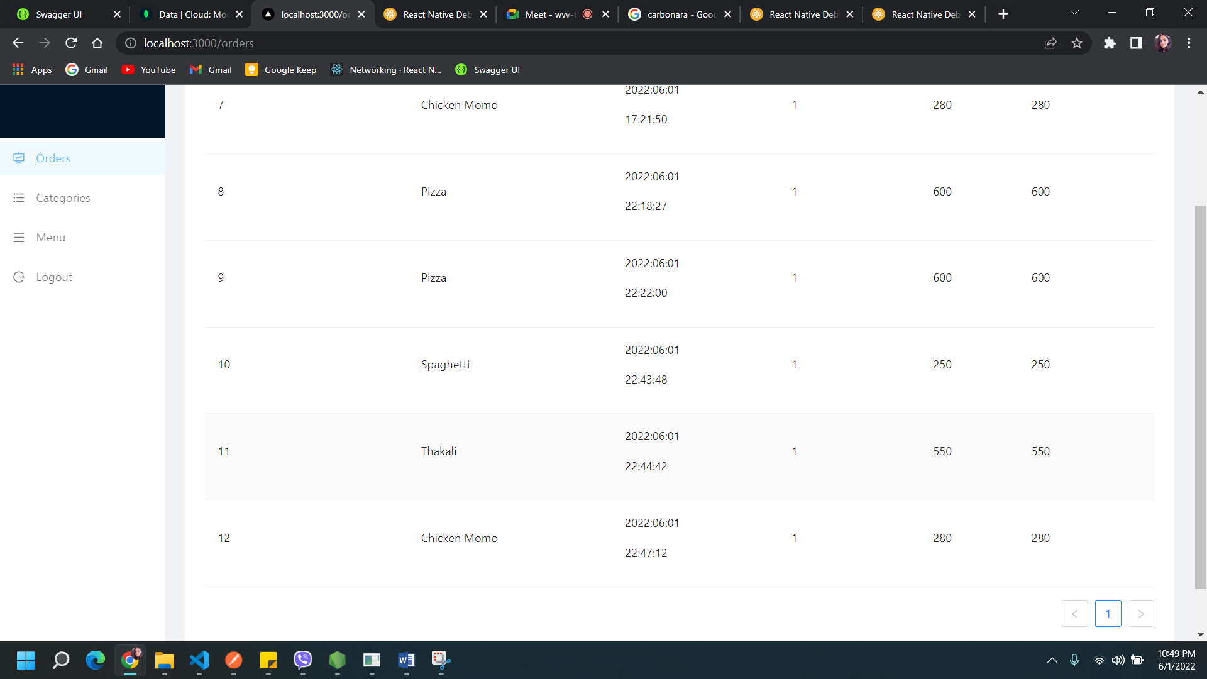

## b) Categories Details

By clicking on the Item menu on side menu bar, admin can see the categories of the items.

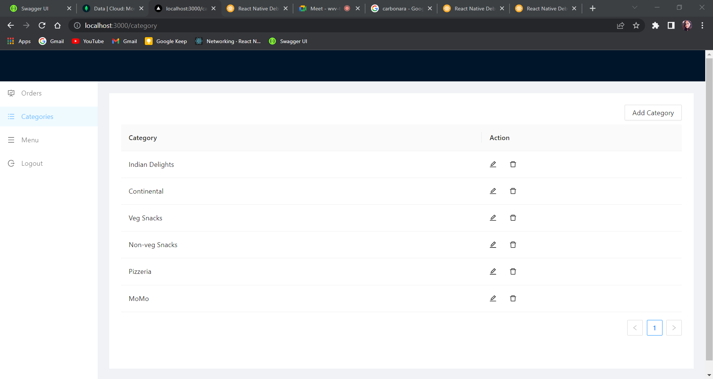

Also, a category can be added by clicking on ‘Add Category’ button.

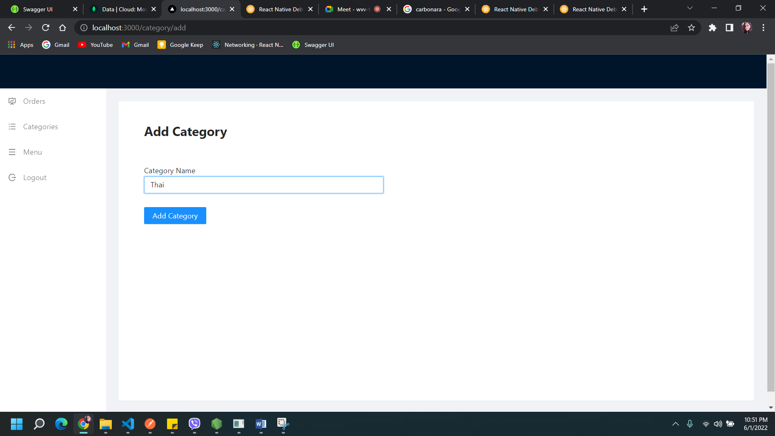

A new category is added.

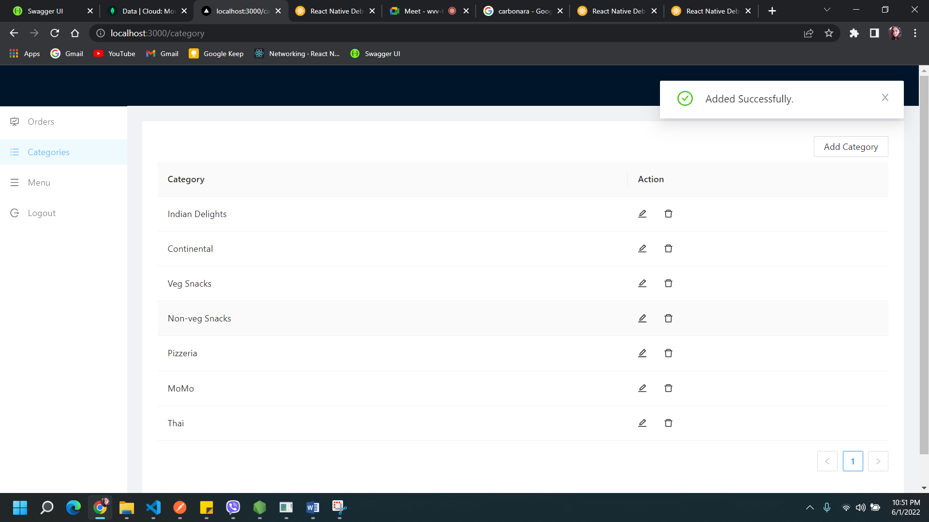

The edit and delete features are also included.

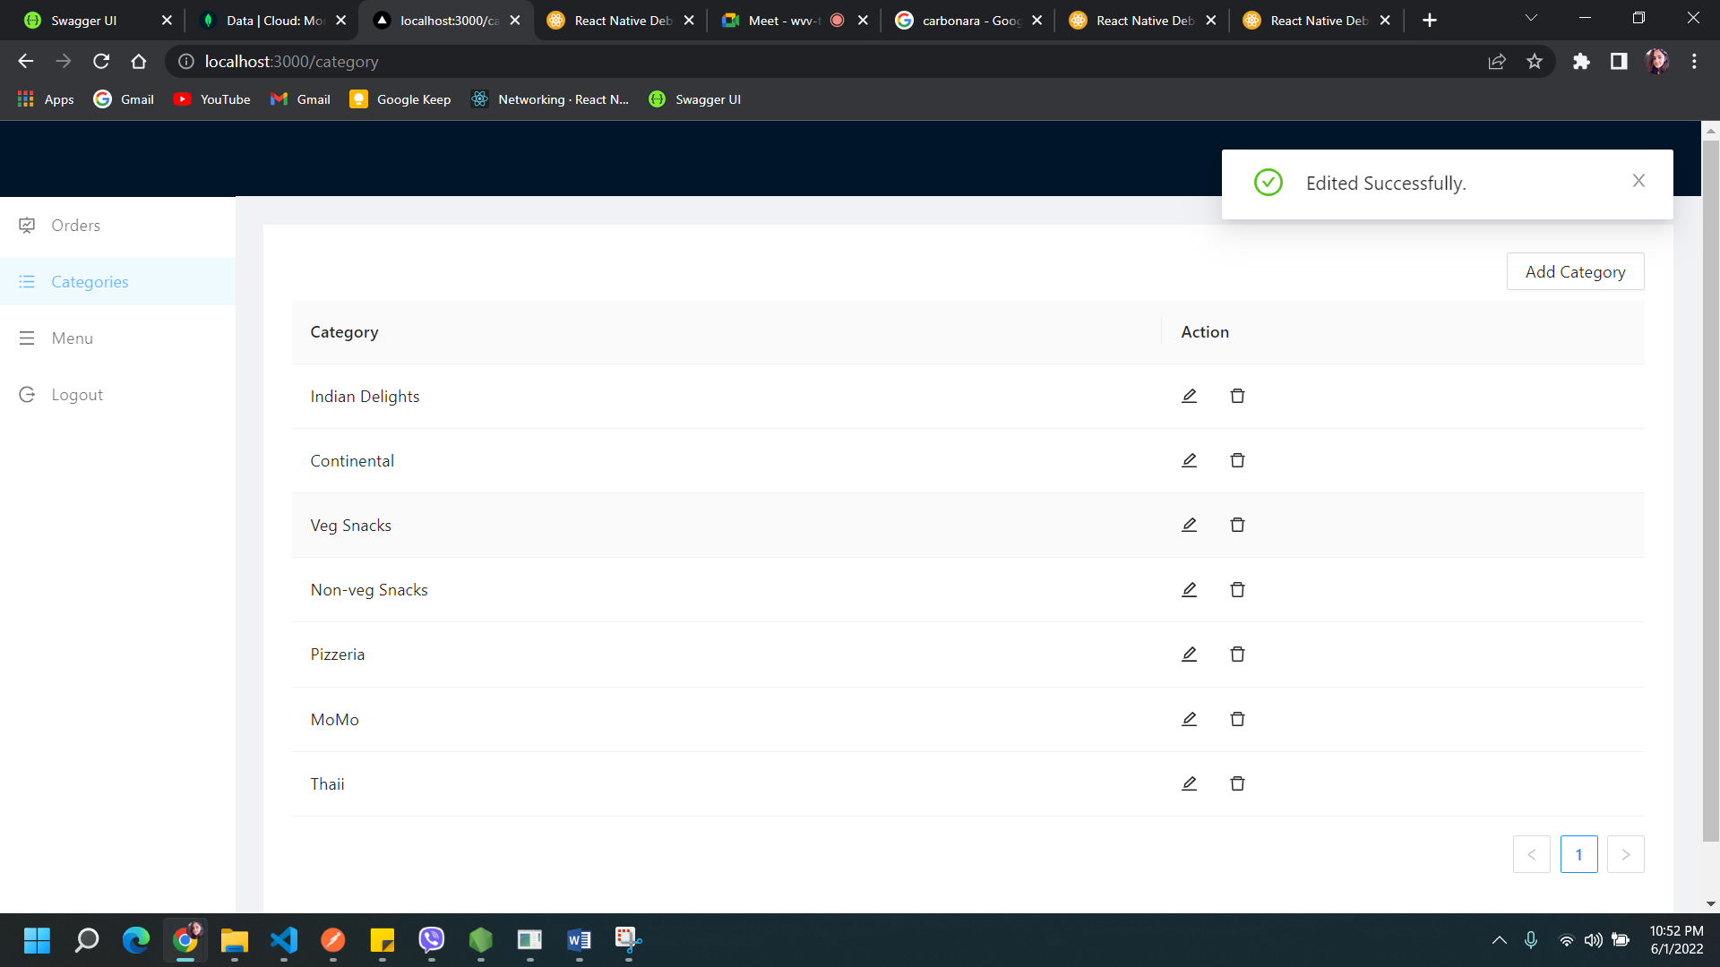

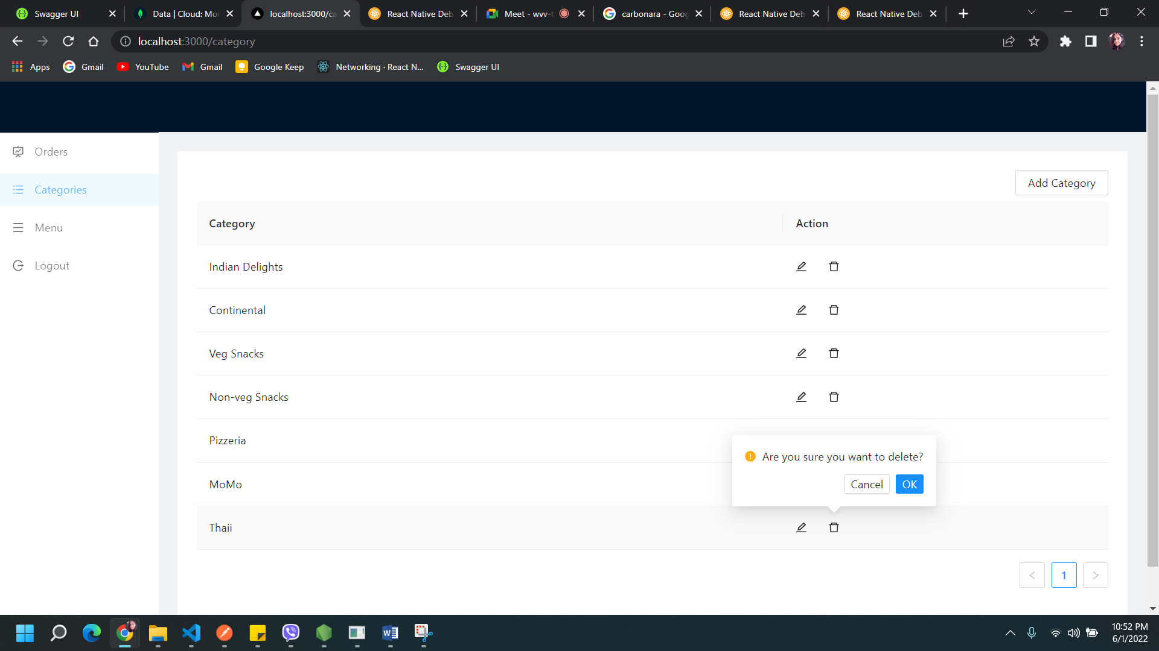

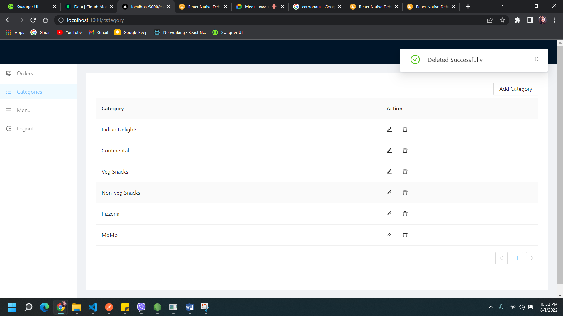

## c) Menu Details

By clicking on the Menu Details, the admin is able to view the detailed information of the food items.

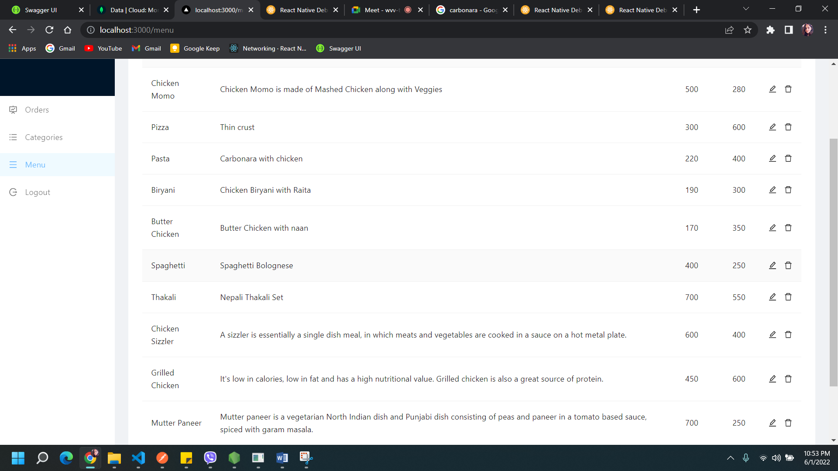

The admin can add, update and delete from the menu items provided.

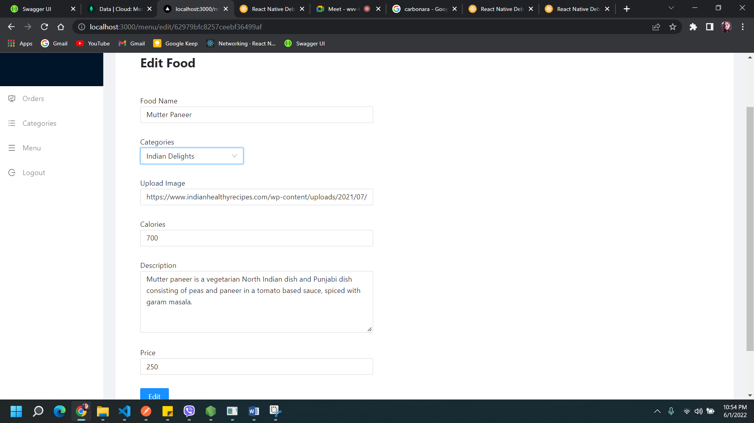

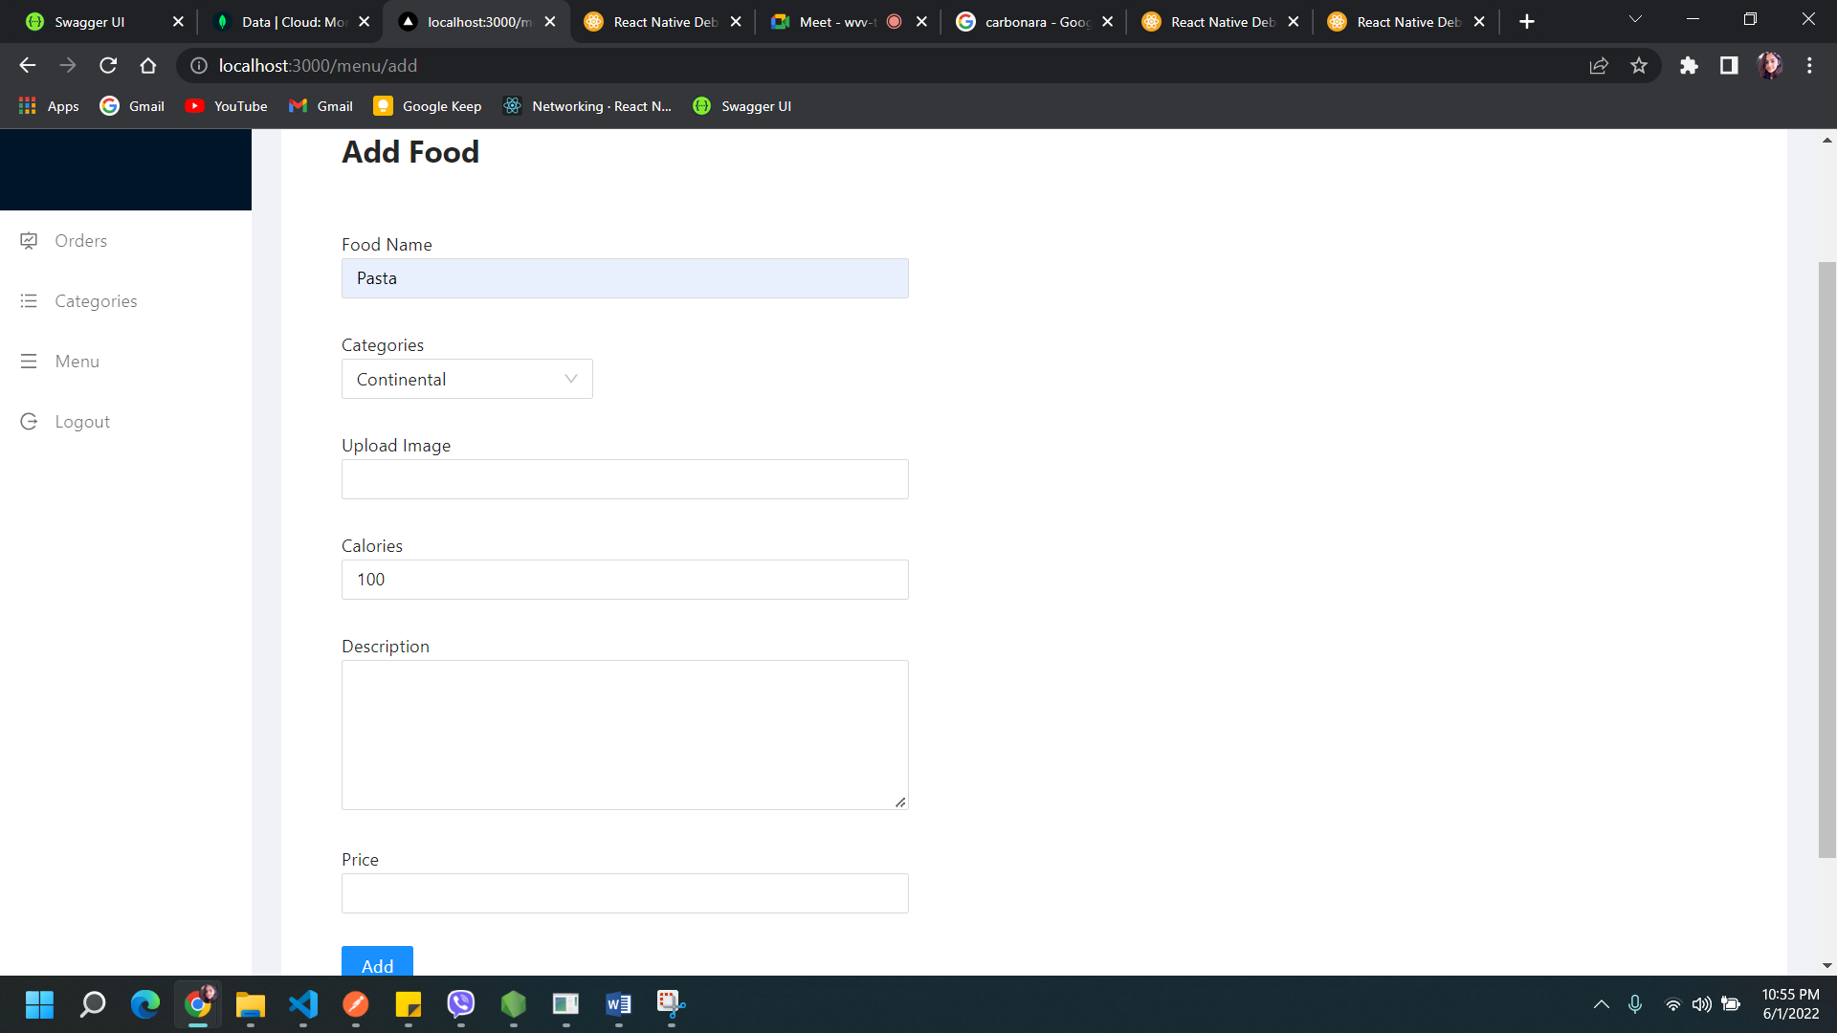

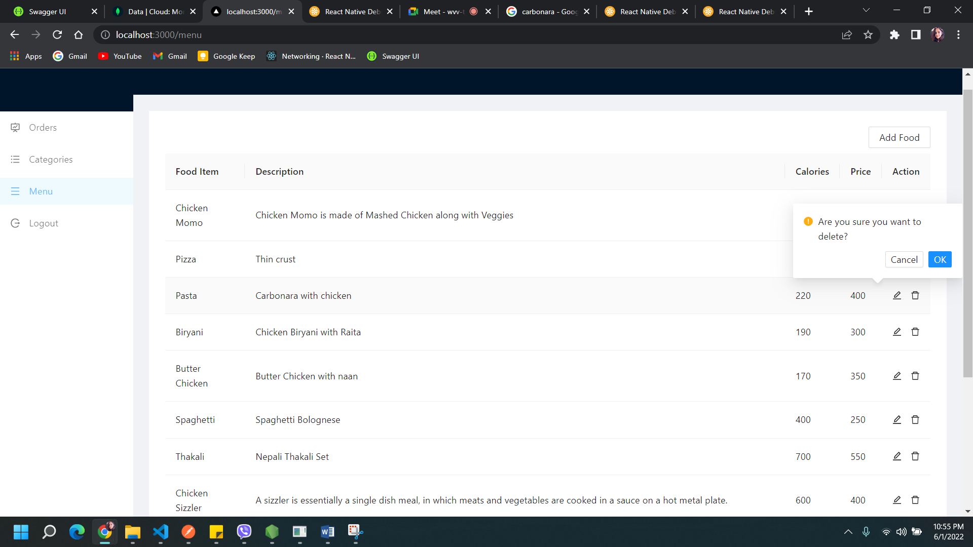

# 4) Logging Out

The admin will be able to log out from the dashboard by clicking on Logout button. After logging out, they will be redirected to the login page.

